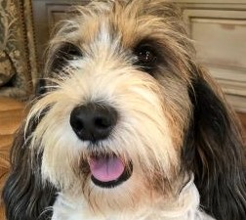  To learn about PBGVs scan this:  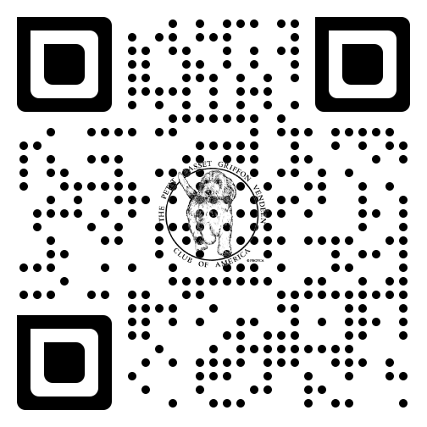 | To learn about PBGVs scan this:
To learn about PBGVs scan this: | To learn about PBGVs scan this:
To learn about PBGVs scan this: | To learn about PBGVs scan this:
To learn about PBGVs scan this: | To learn about PBGVs scan this:
To learn about PBGVs scan this: | To learn about PBGVs scan this:
Petit Basset Griffon Vendéen  Peh-TEE Bah-SAY Gree-FOHN Vehn-DAY-uhn  Since that’s hard to say, we’re also known as PBGVs. We are French hounds, bred to hunt rabbit or hare. Our name says a lot about us: Petit - small; Basset - low to the ground; Griffon - rough coated; and Vendéen - the area of France where we originated. We are known as The Happy Breed.  www.pbgv.org | Petit Basset Griffon Vendéen  Peh-TEE Bah-SAY Gree-FOHN Vehn-DAY-uhn  Since that’s hard to say, we’re also known as PBGVs. We are French hounds, bred to hunt rabbit or hare. Our name says a lot about us: Petit - small; Basset - low to the ground; Griffon - rough coated; and Vendéen - the area of France where we originated. We are known as The Happy Breed.  www.pbgv.org
Petit Basset Griffon Vendéen  Peh-TEE Bah-SAY Gree-FOHN Vehn-DAY-uhn  Since that’s hard to say, we’re also known as PBGVs. We are French hounds, bred to hunt rabbit or hare. Our name says a lot about us: Petit - small; Basset - low to the ground; Griffon - rough coated; and Vendéen - the area of France where we originated. We are known as The Happy Breed.  www.pbgv.org | Petit Basset Griffon Vendéen  Peh-TEE Bah-SAY Gree-FOHN Vehn-DAY-uhn  Since that’s hard to say, we’re also known as PBGVs. We are French hounds, bred to hunt rabbit or hare. Our name says a lot about us: Petit - small; Basset - low to the ground; Griffon - rough coated; and Vendéen - the area of France where we originated. We are known as The Happy Breed.  www.pbgv.org
Petit Basset Griffon Vendéen  Peh-TEE Bah-SAY Gree-FOHN Vehn-DAY-uhn  Since that’s hard to say, we’re also known as PBGVs. We are French hounds, bred to hunt rabbit or hare. Our name says a lot about us: Petit - small; Basset - low to the ground; Griffon - rough coated; and Vendéen - the area of France where we originated. We are known as The Happy Breed.  www.pbgv.org | Petit Basset Griffon Vendéen  Peh-TEE Bah-SAY Gree-FOHN Vehn-DAY-uhn  Since that’s hard to say, we’re also known as PBGVs. We are French hounds, bred to hunt rabbit or hare. Our name says a lot about us: Petit - small; Basset - low to the ground; Griffon - rough coated; and Vendéen - the area of France where we originated. We are known as The Happy Breed.  www.pbgv.org
Petit Basset Griffon Vendéen  Peh-TEE Bah-SAY Gree-FOHN Vehn-DAY-uhn  Since that’s hard to say, we’re also known as PBGVs. We are French hounds, bred to hunt rabbit or hare. Our name says a lot about us: Petit - small; Basset - low to the ground; Griffon - rough coated; and Vendéen - the area of France where we originated. We are known as The Happy Breed.  www.pbgv.org | Petit Basset Griffon Vendéen  Peh-TEE Bah-SAY Gree-FOHN Vehn-DAY-uhn  Since that’s hard to say, we’re also known as PBGVs. We are French hounds, bred to hunt rabbit or hare. Our name says a lot about us: Petit - small; Basset - low to the ground; Griffon - rough coated; and Vendéen - the area of France where we originated. We are known as The Happy Breed.  www.pbgv.org
Petit Basset Griffon Vendéen  Peh-TEE Bah-SAY Gree-FOHN Vehn-DAY-uhn  Since that’s hard to say, we’re also known as PBGVs. We are French hounds, bred to hunt rabbit or hare. Our name says a lot about us: Petit - small; Basset - low to the ground; Griffon - rough coated; and Vendéen - the area of France where we originated. We are known as The Happy Breed.  www.pbgv.org | Petit Basset Griffon Vendéen  Peh-TEE Bah-SAY Gree-FOHN Vehn-DAY-uhn  Since that’s hard to say, we’re also known as PBGVs. We are French hounds, bred to hunt rabbit or hare. Our name says a lot about us: Petit - small; Basset - low to the ground; Griffon - rough coated; and Vendéen - the area of France where we originated. We are known as The Happy Breed.  www.pbgv.org

